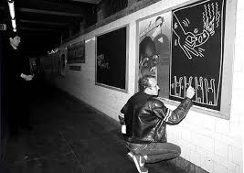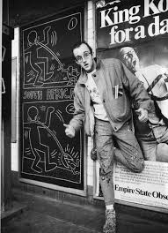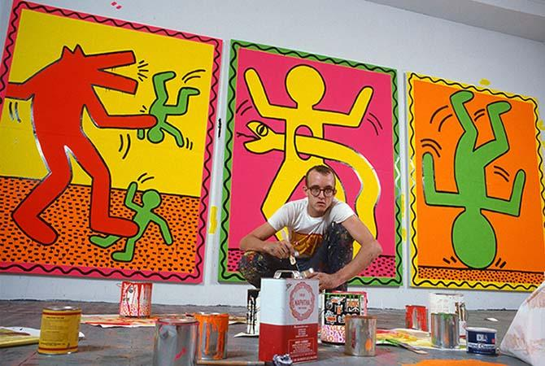<https://www.youtube.com/watch?v=C5WMb4589Gw&feature=emb_title>

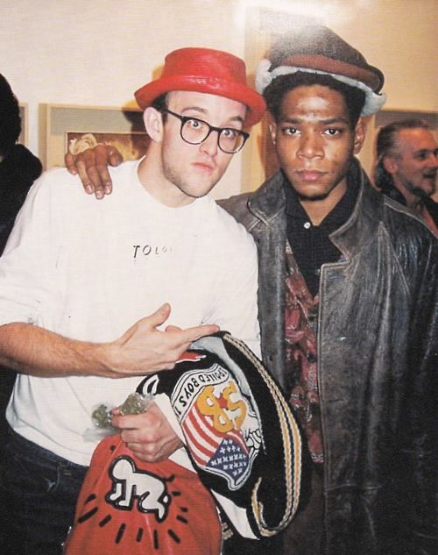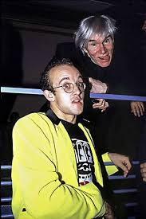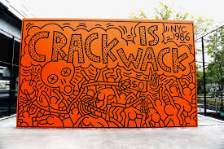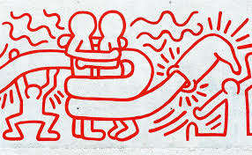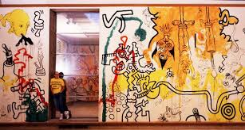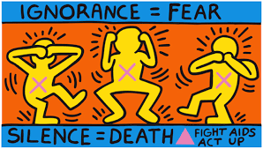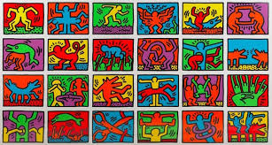

Slide 1: Early Life

* Originally from Reading Pennsylvania
* Got into drawing at a very young age- cartooning
* Attended Ivy School of Professional Art in Pittsburgh(a commercial art school) but dropped out after two semesters
* In 1978 he had his first exhibition at the Pittsburgh Arts and Crafts center
* Later that year he moved to New York and enrolled at the School of visual arts
* Haring found a vibrant art community that was developing outside the gallery and museum system, in the downtown streets, the subways, and spaces in clubs and former dance halls. He was inspired by the energy and decided to open many exhibitions at Club 57 and other venues.

Slide 2: Graffiti (for script)

* Often used chalk instead of spray paint
* Saw graffiti as a way to practice and experiment
* Drew on empty advertisement space in the subway

Slide 3: His social circle

Basquiat

* Within the street art community, Haring created friendships with other artists including Jean-Michel Basquiat
* Basquiat and Haring were both friends and rivals
* Both of their art was against racism, commodification, and oppression.
* They both died from two of the major scourges of the times: Haring of HIV/Aids-related cancer and Basquiat of a drug overdose.

Warhol

* Haring and Warhol had similar artistic styles and were involved in the same underground art community.
* Haring was inspired by Warhol
* Haring also formed a close friendship with Madonna and, when he was invited to her wedding, he took Andy Warhol as his plus one.

Slide 4: His artistic style

* kind of pop-art, kind of comic, with his own twist
* Bright colors, cartoonish

Slide 5: Underground exhibitions- Club 57

* Haring was uninterested in the high-class art gallery scene. His audience was young party-goers. Most of his exhibitions were at underground clubs and dance-halls, like Club 57.
* Club 57 blurred the lines between gay and straight, highbrow and lowbrow, art and partying in daring and unprecedented ways. It was a space for creative minds to let loose and have fun

Slide 6: Crack Epidemic

* Haring had friends who had struggled with addiction and he was unsatisfied with the government’s inaction, so he used his art to send a message.
* He painted a bright orange mural reading “crack is wack” on a concrete handball court wall in Harlem River Park at 127th Street
* “As he was wrapping up the final touches, police drove by and gave Haring a court summons for defacing public property (though the artist did not serve time in jail and ultimately paid a reduced fine of $25.) In the days that followed, the mural gained visibility as the media used its image in its coverage of the crack crisis. Eventually, it was vandalized by someone in the neighborhood, and NYC’s Parks Department responded by painting over it with a drab gray. But by that point, the mural’s existence and Haring’s summons had become public knowledge, and the Parks Department commissioner, lamenting its effacement, asked Haring if he would repaint it. Haring agreed, producing a two-sided mural this time, spelling his anti-drug message on both faces of the court wall and altering the original imagery.”

Slide 7: AIDS Epidemic

* Haring was diagnosed with AIDS in 1988.
* He used his art to raise awareness about aids and speak on his illness.
* In 1990, Haring died of AIDS at the age of 31.

Slide 8: Haring Foundation

* In their own words, “The mission of the Keith Haring Foundation is to sustain, expand, and protect the legacy of Keith Haring, his art, and his ideals. The Foundation supports not-for-profit organizations that assist children, as well as organizations involved in education, prevention, and care related to AIDS.”
* The Keith Haring Foundation primarily serves its cause by offering grants, and previous grant recipients include
* In addition to its charitable cause, the Foundation also serves a historical purpose in maintaining and protecting Haring’s art. They also hold archives of historical information about him and the times and places he lived.